**DevOps Demo**

Developpers ---🡪 Test ----🡪 Released to production (IT Operations)

- Devops is combination of set of tools, practices which automates the process between dev and ops

BEFORE Devops

* There was no full automation, this leads to less productivity
* There was no communication or collaboration between Dev and Ops team. (no communication means process will have some struggles)
* Releases cycles used to about 6 months, time to market is slow (customers has to wait till the feature gets to the prod)
* There was no continuous integration, which gives late feedback and that causes complete rework.

Devops:

* Fully automated
* Dev and ops team must work as a single team.
* We follow Agile, i.e. shot releases (1-2 Weeks)
* We follow continuous integration (developers commits changes several times a day and it is automatically built and tested ,if any bugs found an automated email is sent.)
* We follow continuous Deployments. (
* We follow continuous delivery. (some one needs to be approved ,manual Aprroval is required before deploying to production) **IQ**
* Configurtion Management( For Example Ansible 🡪ex: patching )
* Microservices,Dockers,Kubernetes. ( fb divided in to smaller services earlier it was big app)
* Monitoring
* Log management
* Etc ..

17-10-19

Any operation

I am deleting a branch in local and I am pushing that changes t0 remote

# git push -d origin task-5

**IQ** )Git Merging strategies

Git has different strategies :

Git depending on the context uses one of the following merging strategies

* Fast forward strategies
* Recursive or 3-way merge
* Rebase

**Fast forward Merge :**

**Before FFM:**

%3CmxGraphModel%3E%3Croot%3E%3CmxCell%20id%3D%220%22%2F%3E%3CmxCell%20id%3D%221%22%20parent%3D%220%22%2F%3E%3CmxCell%20id%3D%222%22%20value%3D%22Master%22%20style%3D%22rounded%3D0%3BwhiteSpace%3Dwrap%3Bhtml%3D1%3B%22%20vertex%3D%221%22%20parent%3D%221%22%3E%3CmxGeometry%20x%3D%22240%22%20y%3D%2240%22%20width%3D%2270%22%20height%3D%2230%22%20as%3D%22geometry%22%2F%3E%3C%2FmxCell%3E%3C%2Froot%3E%3C%2FmxGraphModel%3E

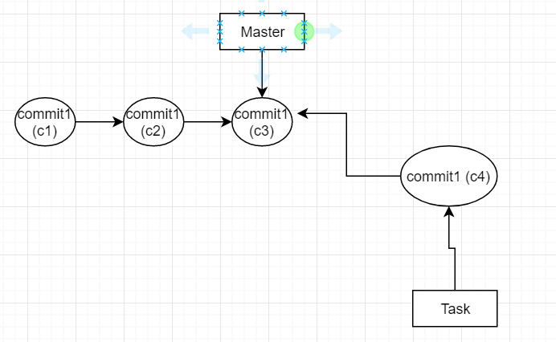

**After t**ask branch is created from master at c3 there are no new commits in the master In this case if we merge git uses fast forward merge.

**After ffwd merge:::::::**

Master is moved to C4

Recursive merge:

After task branch is created from master at c3, master has new commits so git can’t use Fast forward, the option left is recursive merge. It creates a new commit

After recursive :

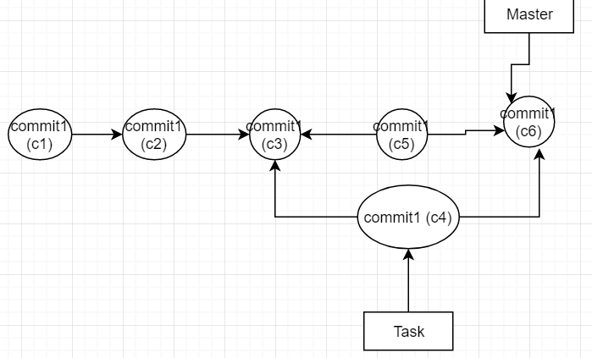

Rebase:

Before rebase

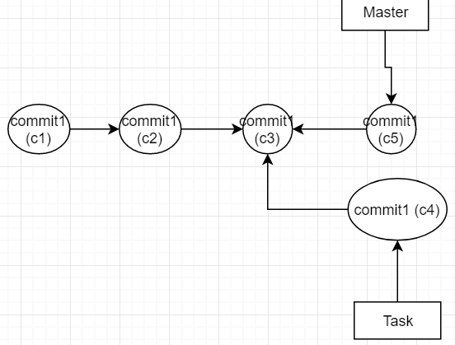

After rebase

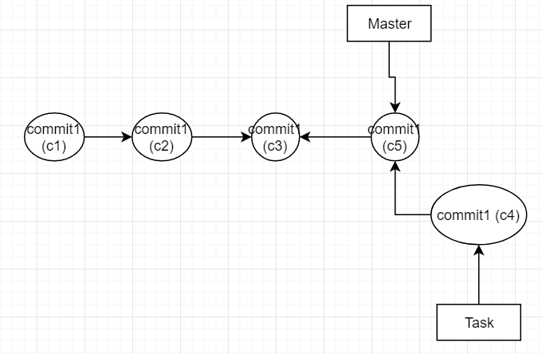

Task : check practically how to use rebase.

**IQ**)What is Git init :

Converts local folder to Git repository

**IQ)** what is bare repository in git:

It’s a repository which does not contain working area and staging area (i.e we can’t do changes to bare repository)

**IQ) : which branching strategy are you using in project : imp**

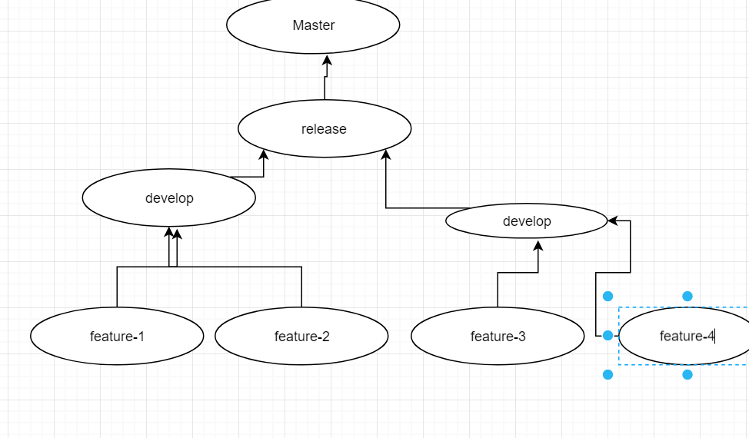

There will be development teams with different names.

**Cherry pick:**

Cherry pick pics only specific commit from the other branch and integrates with current branch

**Tag in Git:**

Tag is a light weight pointer which is used for marking important commits in the history ,it is typically used for versioning releases

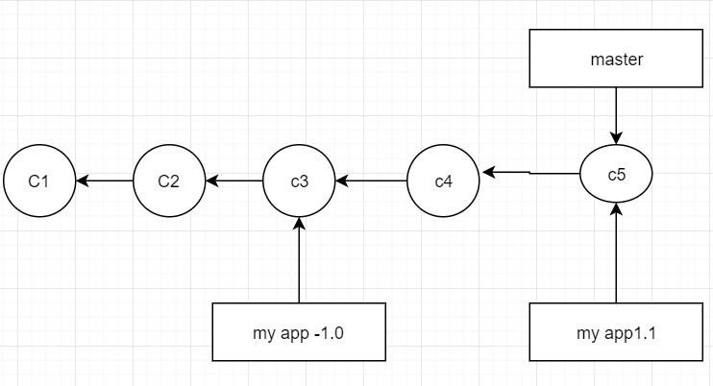

[ same branch commands just to replace }

Command : # git tag myapp-1.0.0 -m ‘releaseone’ ( git tag tagname commit message

# git push origin myapp-1.0.0 ( to push to remote)

# git push origin myapp-1.0.0 -m ‘release 0.1’ 574c4b9 ( for tagging from particular point )

# git tag -d myapp-1.0.0 ( to delete a tag)

**IQ)What is difference between Branch and tag ?**

We create new branch to implement new features and fix defects

We use tags to mark new releases

**IQ)What is Git stash ?**

**-------------------------------------------------------------------------------------------------------------**